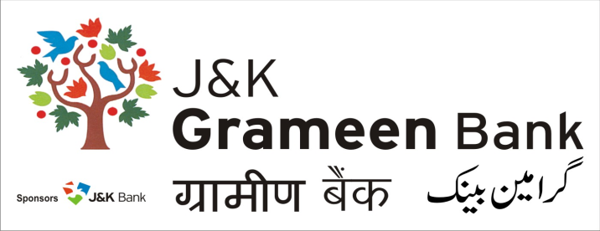
General Administrative Deptt. (GAD)
HEAD OFFICE
NARWAL, JAMMU
Mobile No.: 9797127377
E-mail: pdg.hoj@jkgb.in
Website: www.jkgb.in
--------------------------------------------------------------------------------------------------------------------------
Ref.No: JKGB/GAD/2024-25/6080 Date: 17.12.2024

Rate contract for supply and installation of UPS/Batteries - Extension Notice
This is in reference to tender document having Ref No. JKGB/GAD/2024-25/5274 dated 14-12-2024 regarding Rate contract for supply and installation of UPS/Batteries. In this regard, it is informed that the last date of submission of tender has been extended to 23.12.2024 upto 5:00 P.M. The technical bids shall now be opened on 24.12.2024 at 12:00 Noon at J&K Grameen Bank, Head Office Narwal Jammu.
All other Terms & conditions shall remain the same.

Sd/-
HOD
General Administrative Deptt. (GAD)

