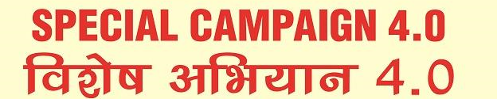
J&K Grameen Bank
Observing

PENSION GRIEVANCE WEEK
W.E.F.
21.10.2024 TO 26.10.2024.

For any grievance, Bank Staff Pensioners/Family pensioners may submit their grievance to respective pension disbursing branch for onward submission to DP&TB Cell, HRDD, H.O. Narwal or they may contact DP&TB Cell, HRDD at email: dptb@jkgb.in, Mob.: 8082187899

