J&K Grameen Bank Head Office, Narwal Ph: 9797127377 E:pdg.hoj@jkgb.in
Near Fruit Complex, Jammu. W: www.jkgb.in
180006 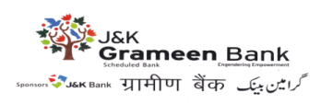
GENERAL ADMINISTRATIVE DEPARTMENT
Ref. No: - JKGB/GAD/ 2025-26/ 136 Dated: 09-04-2025
TENDER NOTICE
J&K Grameen Bank hereby invites tenders regarding rate contract for AMC of Servo-Stabilizers for Branches / Offices of the Bank located in UT of J&K and UT of Ladakh for a period of 02 years. The tender documents can be downloaded from the Bank’s website www.jkgb.in from 09-04-2025 to 02-05-2025. For more information, visit www.jkgb.in
Sd/-
HOD
GENERAL ADMINISTRATIVE DEPARTMENT

